BIOLOGICAL PROFILE ASSIGNMENT

You are a Forensic Anthropologist called to the scene with possible human remains. You will work through the following steps to complete a profile!

RECOVER – Search and Discovery
“The call: A hiker discovers bones they think are human in a remote location and calls the police. The Coroner, whose job it is to investigate suspicious deaths, calls you to help recover the human remains and any other important evidence.”

What are the different methods for locating human remains? Please write your answer in paragraph form.

RECOVER – Excavation
“You have successfully located the gravesite. The next step is the excavation.
Excavation is destructive so you need to work carefully and document what you find. As you dig, you must pay attention to the layers of soil (called strata) and the evidence in each layer. This tells you how the grave was constructed and the timing of events related to it.”

Please give a summary of the process once remains have been located. Please write your answer in paragraph form.

INVENTORY –
“You have located and recovered the remains. Now that they’re back at your lab, it’s time to begin your analysis! The first step is to take a complete inventory of the remains. Your notes show the following:

“Description of Remains:
The remains consist of an almost complete skeleton partially covered with desiccated tissue, partially skeletonized. There was a piece of desiccated torso tissue with a roughly 5mm circular hole found on the remains. There was no odor of decomposition and mild insect activity but no maggot infestation. Light brown-gray head and facial hair was present with the remains. There are no signs of animal activity or sun bleaching, however a white and red mold was present throughout the skeleton. The remains were cleaned with gentle brushing to remove any debris and the remaining desiccated tissue was removed. The bone is brown to dark-brown in color where not covered by tissue—light brown where tissue was removed. Overall the bones are robust both in size and muscle attachment.
The mandible was cleanly fractured at gnathion and found in two separate pieces. Similarly the mandibular dentition show signs of cracking/splitting on the crown and many were found separate from the skull. For analysis purposes, the mandible was restored using glue to connect the left and right body and the teeth were glued into their sockets. There were a number of ossified pieces of bone throughout the skeleton (ossified thyroid cartilage, sesamoid bones, etc). The sternum contains sternotomy wires with bone having healed around and over. There are a number of healed fractures on the ribcage and here is a healing comminuted fracture at the right midlambdoid suture. There is a healing fracture to the right parietal/occipital near the lambdoid suture.
All bones were present except the inner ear ossicles and one intermediate hand phalanx.”

Dental: (1 = upper LM3, 16= upper RM3, 17= lower RM3, 32 = lower LM3)
1 | Absent - AML | 17 | Present, occlusal amalgam
2 | Absent - AML | 18 | Absent – AML
3 | Present, mesio-occlusal amalgam | 19 | Absent – AML
4 | Present, heavy buccal decay/wear, fracture | 20 | Absent – AML
5 | Absent – PML | 21 | Absent – AML
6 | Present | 22 | Present
7 | Present, distal crown chip | 23 | Present
8 | Present | 24 | Present, crown fracture
9 | Present, labial amalgam | 25 | Present, crown fracture
10 | Present, crown decay/chip by CEJ | 26 | Present
11 | Present, root tip (possible retention of deciduous canine) | 27 | Present, diamond dentine exposure
12 | Absent – PML | 28 | Present, root tip
13 | Present, root only | 29 | Present, root tip
14 | Absent – AML | 30 | Absent – AML
15 | Absent – AML | 31 | Absent – AML
16 | Present, occlusal amalgam | 32 | Absent – AML
_{PML: Postmortem Loss} _{AML: Antemortem Loss}

Based on the above, please fill out the skeletal inventory form. Are there any aspects of a biological profile you cannot complete due to missing bones? Please explain your answer.

-Biological Profile:
Estimating Sex: Your notes show the following:

- Skull:
  - Nuchal Crest: scored a 4
  - Mastoid Process: Scored a 3
  - Supraorbital Margin: Scored a 3
  - Glabella: Scored a 4
  - Mental Eminence: Scored a 3
- Pelvis:
  - Ventral Arc: Scored a 3
  - Subpubic Concavity: Scored 2
  - Ischiopubic Ramus: Scored a 3
  - Greater Sciatic Notch: Scored a 4
  - Preauricular Sulcus: Scored a 4
- Other:
  - The sacral ala show a ratio of 1>:<1:1>
  - Sacrum seems longer with an anterior curve towards the coccyx
  - Chin shape is squared
  - Has a slanted Frontal Bone
  - Heart Shaped Pubic Inlet

What sex do you believe this individual was? Why?

Determining Age: Your notes show the following.

- The Left and Right Sternal Clavicle are fused
- There is complete fusion on the sacrum between S1 and S2
- Left and Right 3rd molars are present
- Pubic Symphysis: Given a Brooks and Suchey score of 6.
- Sternal 4th Rib:
  - I: scored a 3
  - II: scored a 4
  - III: scored a 4

What age range do you believe this individual fit into? Why? If referencing Brooks and Suchey, please describe the phase. Please do the same for the Sternal Rib.

Determining Ancestry: Your notes show the below:

- Sharp Nasal Sill
- Narrow Nasal Aperture
- Projecting and sharp Nasal Spine
- High Nasal Bridge
- Angled Orbits
- Narrow Interorbital Distance
- No Maxillary Prognathism
- Retreating Zygomatics
- No Post-bregmatic depression
- Carabelli’s cusp present, high expression
- FORDISC: “Three separate runs were performed in FORDISC 3.1.312. The first was a stepwise run taking all populations and sexes into consideration. FORDISC was unable to classify this individual into any group. A male only stepwise run was then preformed. For this run, FORDISC was able to classify the individual as a white male (WM) with a posterior probability of 0.926. Finally, a postcranial run was performed. This run took the measurements of the innominate, ulna, humerus, femur, and calcaneus into consideration. For this run, FORDISC classified the individual as a WM with a posterior probability of 0.992.”

What ancestry do you believe this individual may be from? Why?

Calculating Stature: Use the measurements provided in the below chart to calculate stature of this individual per the Byer’s formulas (provided).

Humerus
Maximum Length | _{left:}309 mm | _{right:}311 mm
Epicondylar Breadth | _{left:}62 mm | _{right:}63 mm
Max. Vert. Diam. of Head | _{left:}51 mm | _{right:}51 mm
Max. Diam. at Midshaft | _{left:}23 mm | _{right:}25 mm
Min. Diam. at Midshaft | _{left:} 22 mm | _{right:} 20 mm

Radius
Maximum Length | _{left:} 235 mm | _{right:} 238 mm
Sagittal Diam. at MIDSH | _{left:} 17 mm | _{right:} 17 mm
Transv. Diam. at MIDSH | _{left:} 13 mm | _{right:} 13 mm

Ulna
Maximum Length | _{left:} 253 mm | _{right:} 258 mm
Dorso-volar Diameter | _{left:} 15 mm | _{right:} 14 mm
Transverse Diameter | _{left:} 14 mm | _{right:} 15 mm
Physiological Length | _{left:} 227 mm | _{right:} 229 mm
Min. Circumference | _{left:} 38 mm | _{right:} 38 mm

Femur
Maximum Length | _{left:} 457 mm | _{right:}461 mm
Bicondylar Length | _{left:} 452 mm | _{right:}457 mm
Epicondylar Breadth | _{left:} 90 mm | _{right:}90 mm
Max. Diam. of Head | _{left:} 48 mm | _{right:}49 mm
A/P Subtroch. Diam. | _{left:} 36 mm | _{right:}35 mm
Transv. Subtroch. Diam. | _{left:} 32 mm | _{right:}33 mm
Sagittal Diam. at MIDSH | _{left:} 29 mm | _{right:}29 mm
Transv. Diam. at MIDSH | _{left:} 33 mm | _{right:} 31 mm
Circumference at MIDSH | _{left:} 95 mm | _{right:} 95 mm

Tibia
Condyl-malleolar L. | _{left:} 371 mm | _{right:} 371 mm
Max. Prox. Epiphyseal Br. | _{left:} 83 mm | _{right:} 83 mm
Max. Dist. Epiphyseal Br. | _{left:} 59 mm | _{right:} 57 mm
Max. Diam. at Nutrient For. | _{left:} 28 mm | _{right:} 27 mm
Transv. Diam. at Nutrient For. | _{left:} 34 mm | _{right:} 36 mm
Circum. At Nutrient For. | _{left:} 94 mm | _{right:} 102 mm

Fibula
Maximum Length | _{left:} 370 mm | _{right:} 377 mm
Max. Diam. at Midshaft | _{left:} 14 mm | _{right:} 15 mm

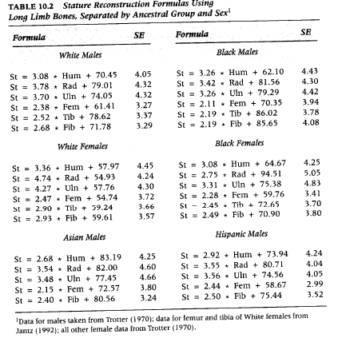

Trauma and Pathology Assessment: Your notes show the following:

- The mandible is fractured into two pieces, fracture located at the eminence (chin). The fracture is the same color as the surrounding bone and there is no healing.
- The left 5th Rib is fractured at the head. The fracture is white around the edges, different from the surrounding bone, and shows no healing.
- There is a fracture located on the Right Lambdoid suture. It radiates across the suture into the Parietal bone. It shows signs of healing, with some obliteration of the fracture lines present.

From the above, how would you classify each trauma? Why?

Further, when looking for pathology, you noted the following:

- Arthritic lipping on the arm bones, leg bones, feet, and vertebrae
- Osteophytes on the Thoracic Vertebrae
- Hypertrophic lesions on the endocranial surface
- Medical Hardware on the Left Femoral Head.

What pathologies do you feel are present based off this information?

REPORT – Now you will write a Forensic Anthropology report! There is an example of a report on BB. You will copy this format and write a report utilizing the information collected from the program and your manual stature calculations.

I have included FORDISC results below – these will help you confirm you ANCESTRY and your SEX.

I have included a case history and description of the remains below.

CASE NUMBER: BIOPROFFALL20
ME CASE NUMBER: MEFALL20
Your name should go where “Amanda J. Brady” is
Please include the due date as date of analysis

Case History:
Per the report by the Death Investigator, the remains were found by the Trenton Fire Department during a welfare check. The remains were found in the second story bedroom. They were on a carpeted floor, parallel to the bed with head towards the closet and feet towards the window with the head turned right. Still on the remains were blue pants, white socks, and brown boots. Found near the remains was a blue Trenton Psychiatric Hospital button-down shirt. The remains were transported to the Middlesex County Medical Examiner’s Office (ME). Per the request of Dr. Stephen Melito, an initial review was completed by the anthropologist at the ME’s office. The bones were then transported to the New Jersey State Police Office of Forensic Science Anthropology Unit for further analysis.

Description of Remains:
The remains consist of an almost complete skeleton partially covered with desiccated tissue, partially skeletonized. There was a piece of desiccated torso tissue with a roughly 5mm circular hole found on the remains. There was no odor of decomposition and mild insect activity but no maggot infestation. Light brown-gray head and facial hair was present with the remains. There are no signs of animal activity or sun bleaching, however a white and red mold was present throughout the skeleton. The remains were cleaned with gentle brushing to remove any debris and the remaining desiccated tissue was removed. The bone is brown to dark-brown in color where not covered by tissue—light brown where tissue was removed. Overall the bones are robust both in size and muscle attachment.

The mandible was cleanly fractured at gnathion and found in two separate pieces. Similarly the mandibular dentition show signs of cracking/splitting on the crown and many were found separate from the skull. For analysis purposes, the mandible was restored using glue to connect the left and right body and the teeth were glued into their sockets. There were a number of ossified pieces of bone throughout the skeleton (ossified thyroid cartilage, sesamoid bones, etc). The sternum contains sternotomy wires with bone having healed around and over. There are a number of healed fractures on the ribcage and here is a healing comminuted fracture at the right midlambdoid suture. There is a healing fracture to the right parietal/occipital near the lambdoid suture.

All bones were present except the inner ear ossicles and one intermediate hand phalanx.

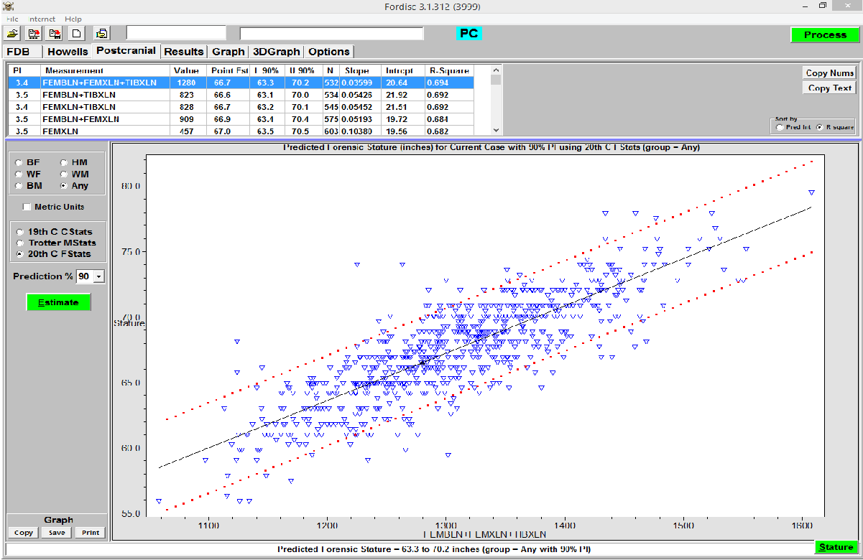
ABOVE: FORDISC STATURE ESTIMATE

